**Types of Information Systems:**

* **Computer-based information system (CBIS**):

Set of hardware, software, databases, telecommunications and procedures configured to collect, manipulate, store, and process data into information.

* **Business Information Systems:**

Business Information System is a group of interrelated components that work collectively to carry out input, processing, storage, output and control actions in order to convert data into information products. These products can be used to support forecasting , planning, control, co-ordination, decision making and operational activities in an organization.

**Types of Business Information Systems**

**Executive Support System**

An Executive Support System ("ESS") is designed to help senior management to make strategic decisions  by providing easy access to both **internal and external** information.It is also called Decision support system.

**Enterprise Resource Planning**

* Integrated programs capable of managing a company’s vital business operations for an entire multisite organization
* Coordinate planning, inventory control, production, and ordering
* Examples oracle netsuit erp,Bizautomation.

**Management Information System**

MIS is mainly concerned with **internal**

sources of information and summarizes it

into a series of management reports.

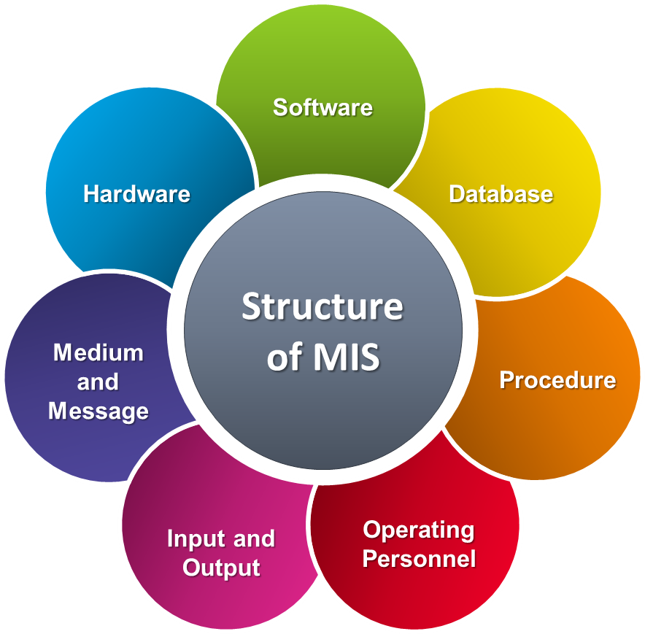

**Transaction Processing Systems:**

**Transaction processing system (TPS):** organized collection of people, procedures, software, databases, and devices used to record completed business transactions.Banking Systems and Payroll Systems.